

Name: Adil Khan

Department: BS AI

Roll no: 2330-0030

Subject: Object Oriented Programming

Teacher: Mam Saba Awan

**Lab # 03**

Task no 1:

#include <iostream>

#include <string>

using namespace std;

class BankAccount {

private:

string accountHolderName;

string accountNumber;

double balance;

bool validateAmount(double amount) {

return amount > 0;

}

public:

BankAccount(string name, string accNo, double initialBalance) {

accountHolderName = name;

accountNumber = accNo;

if (validateAmount(initialBalance)) {

balance = initialBalance;

}

else {

balance = 0;

}

}

void deposit(double amount) {

if (validateAmount(amount)) {

balance += amount;

cout << "Deposited: " << amount << " to your account.\n";

}

else {

cout << "Invalid deposit amount. Please enter a positive value.\n";

}

}

void withdraw(double amount) {

if (validateAmount(amount)) {

if (balance >= amount) {

balance -= amount;

cout << "Withdraw: " << amount << " from your account.\n";

}

else {

cout << "Insufficient funds. Withdrawal failed.\n";

}

}

else {

cout << "Invalid withdrawal amount. Please enter a positive value.\n";

}

}

void displayAccountInfo() {

cout << "Account Holder Name: " << accountHolderName << endl;

cout << "Account Number: " << accountNumber << endl;

cout << "Account Balance: Rs" << balance << endl;

}

};

int main() {

BankAccount account("Adil", "1234", 1000);

account.displayAccountInfo();

account.deposit(500);

account.withdraw(200);

account.withdraw(1500);

account.displayAccountInfo();

return 0;

}

Output:

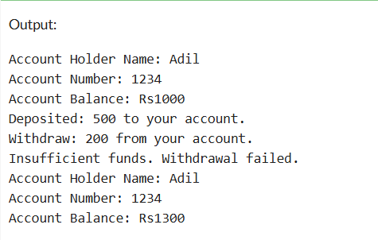

Task no 2:

#include <iostream>

#include <string>

using namespace std;

class Student {

int age;

int cnic;

int semester;

string name;

public:

Student() {

cout << "Student object created!" << endl;

age = 0;

cnic = 0;

semester = 0;

name = "";

}

Student(int a, int c, int s, string n) {

cout << "Student object created with parameters!" << endl;

age = a;

cnic = c;

semester = s;

name = n;

}

~Student() {

cout << "Student object destroyed!" << endl;

}

void setall(int a, int c, int s, int sem, string n) {

age = a;

cnic = c;

semester = s;

name = n;

}

void displayall() {

cout << "The entered data is: " << endl;

cout << "Age: " << age << endl;

cout << "CNIC: " << cnic << endl;

cout << "Semester: " << semester << endl;

cout << "Name: " << name << endl;

}

void setAge(int a) {

age = a;

}

};

int main() {

Student obj;

obj.setall(20, 123456789, 2, 4, "Adil Khan");

obj.displayall();

Student anotherObj;

anotherObj.setall(22, 987654321, 3, 6, "Taha");

anotherObj.displayall();

return 0;

}

Output:

